1. IAM settings are region specific or Not?

we can see the right side global button then it clearly shows IAM does not require region specific.

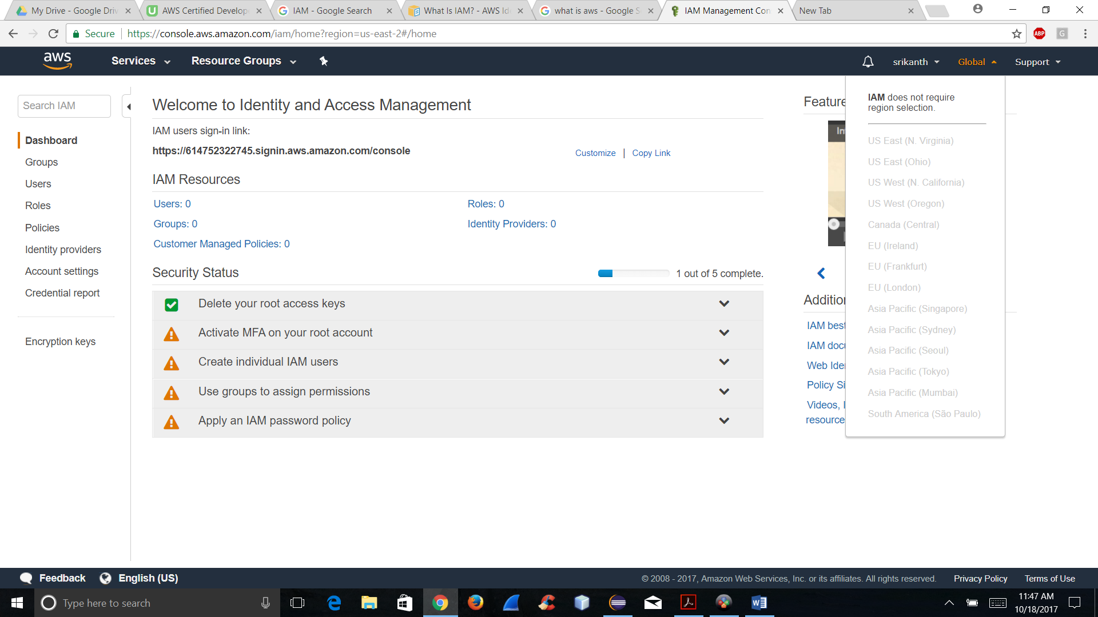

1. By default users have no permissions when first added.

The below screen short clearly says users doesn’t need permissions when first added.

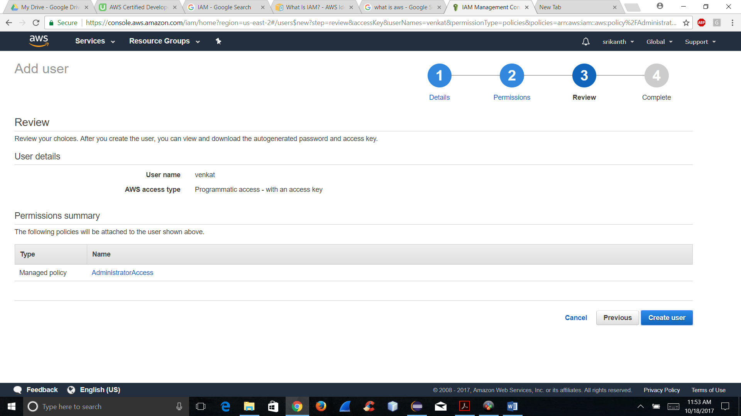

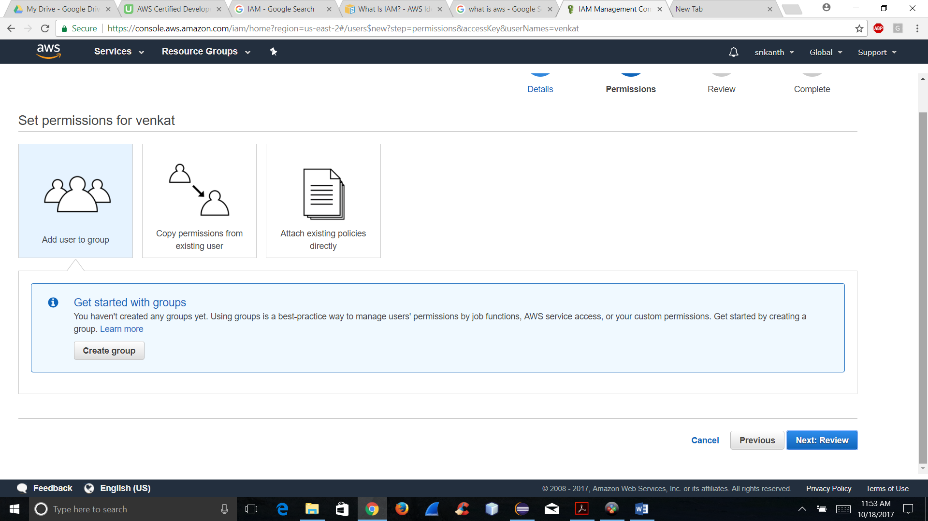

We can add the users manually if we want to add.

3.Active Directory Federation (AD) can authenticate to AWS with AD using SMAL.

Yes we can authenticate ADF to AWS by using Security Assertion Markup Language(SMAL).

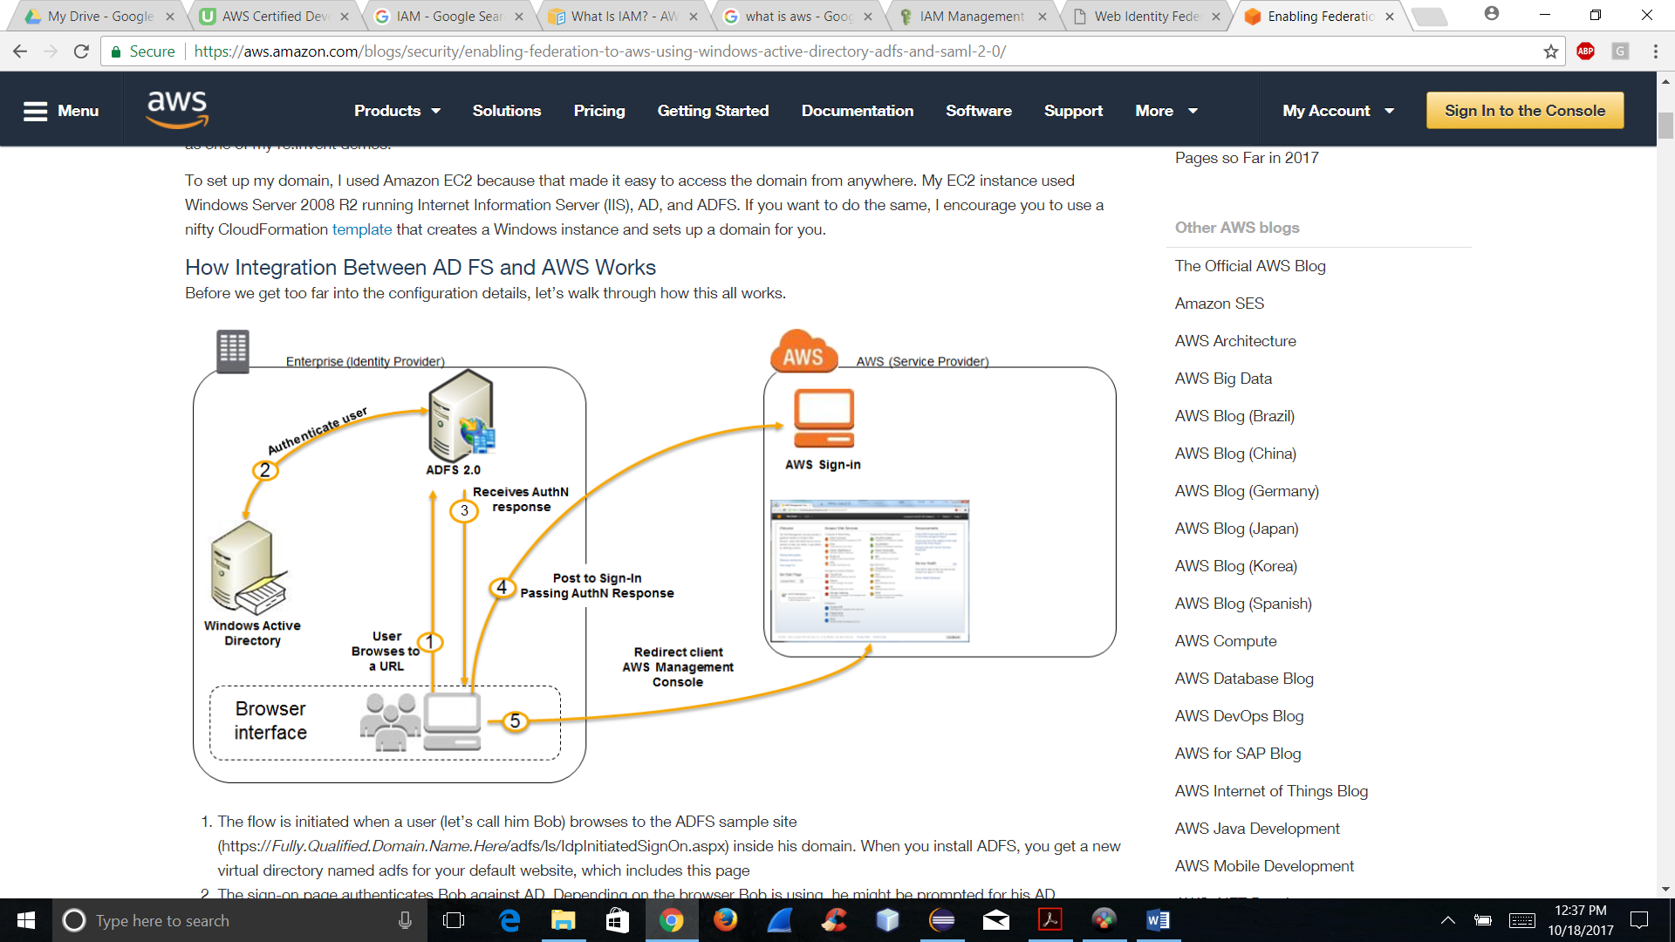

4.Web Identity Federation to AWS via Facebook or any other social sites.

Yes web Identity to AWS via google site is successful as shown in the below snap short.

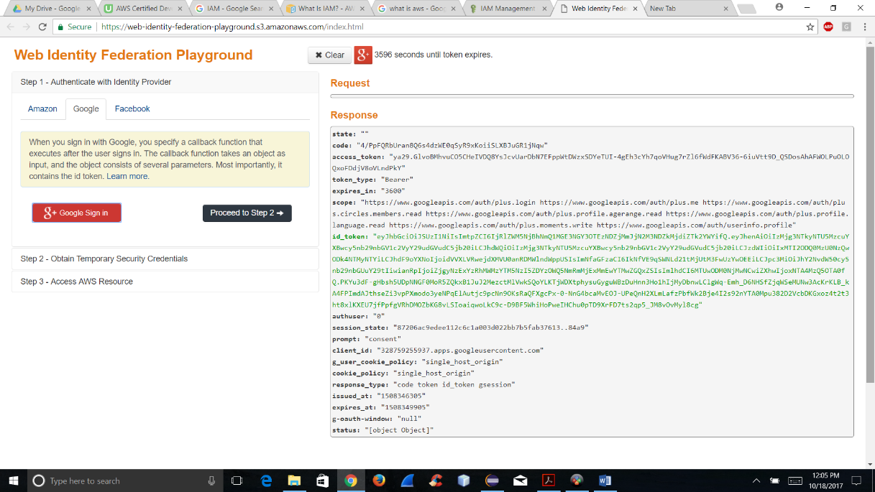

5. AssumeRoleWithWebIdentity Api call used to obtain temporary security credentials when authenticating using web identity federation?

By using AssumeRoleWithWebIdentity Api call we can get authentication to AWS then after we can use the AWS resources like ListBucket s3 and get object.

